Teacher Portal Pro

* **Overview :-**
* If We Run this Code we get the Main **Login Screen**

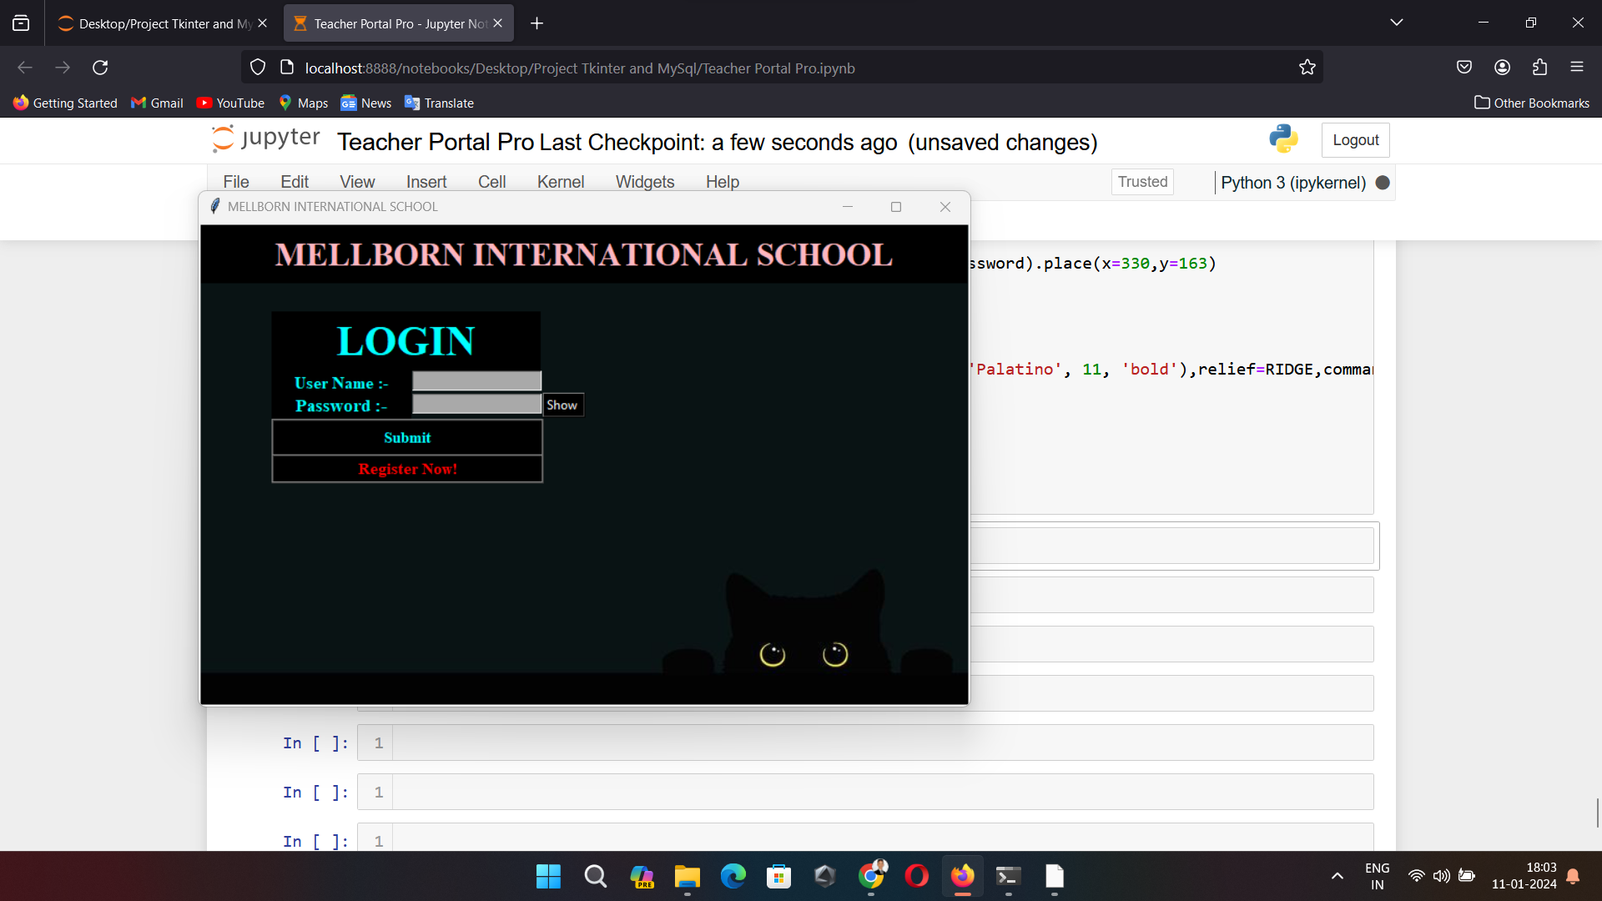

* If The user fill the wrong **Id** or **Password** so it will Show Error **i.e, Invalid Username or Password and the Refresh button will occurs.**

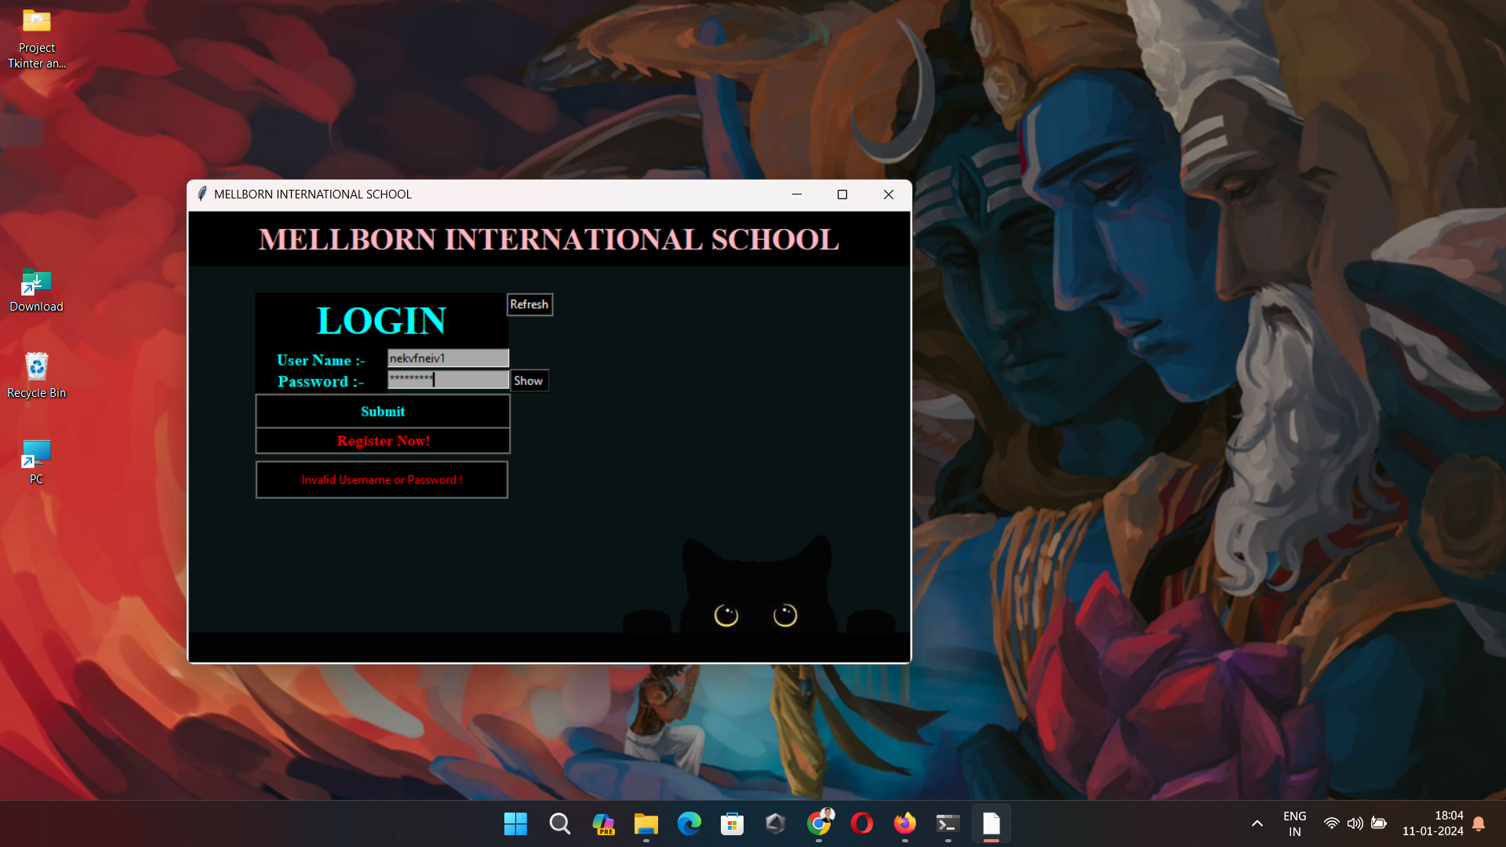

* After Clicking on **Refresh Button** the Page will get Refresh automatically.

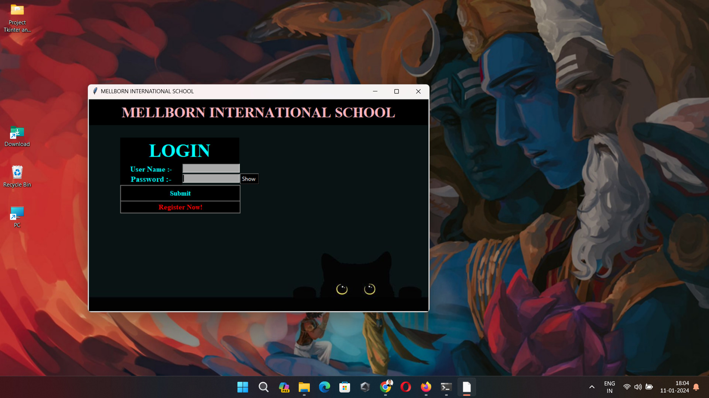

* Now lets move towards Register page by clicking **Register Now!** Button.

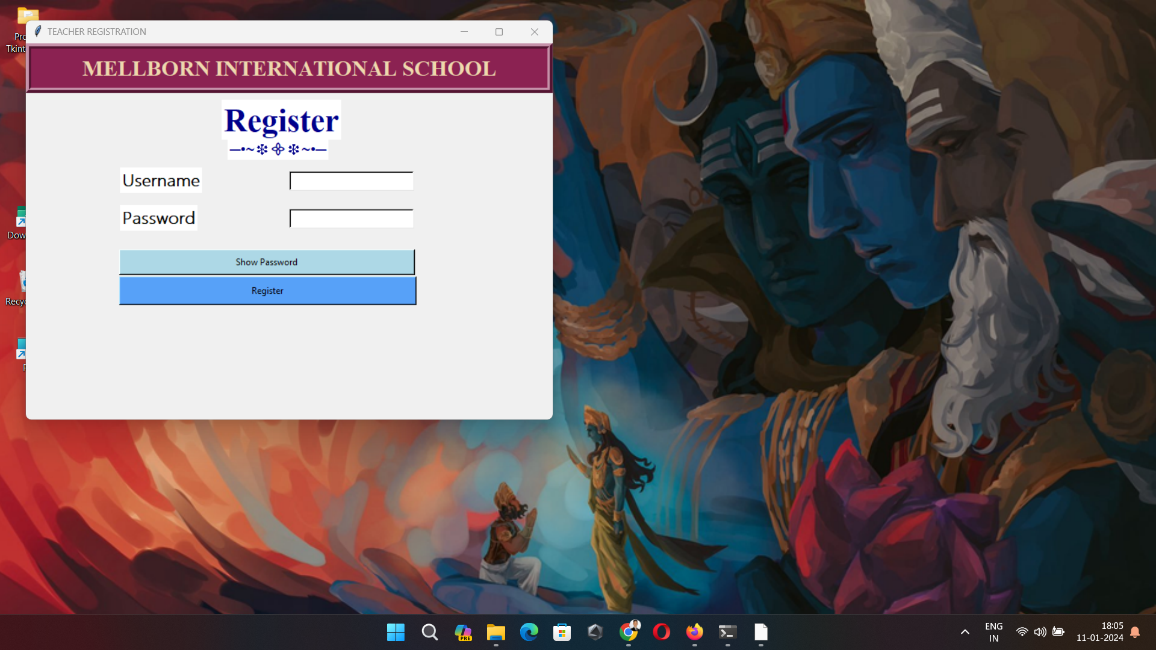

* If we entered the same Id and Password that has been used, So it will show the message box that **Username and Password are already used. Please try a different one**.

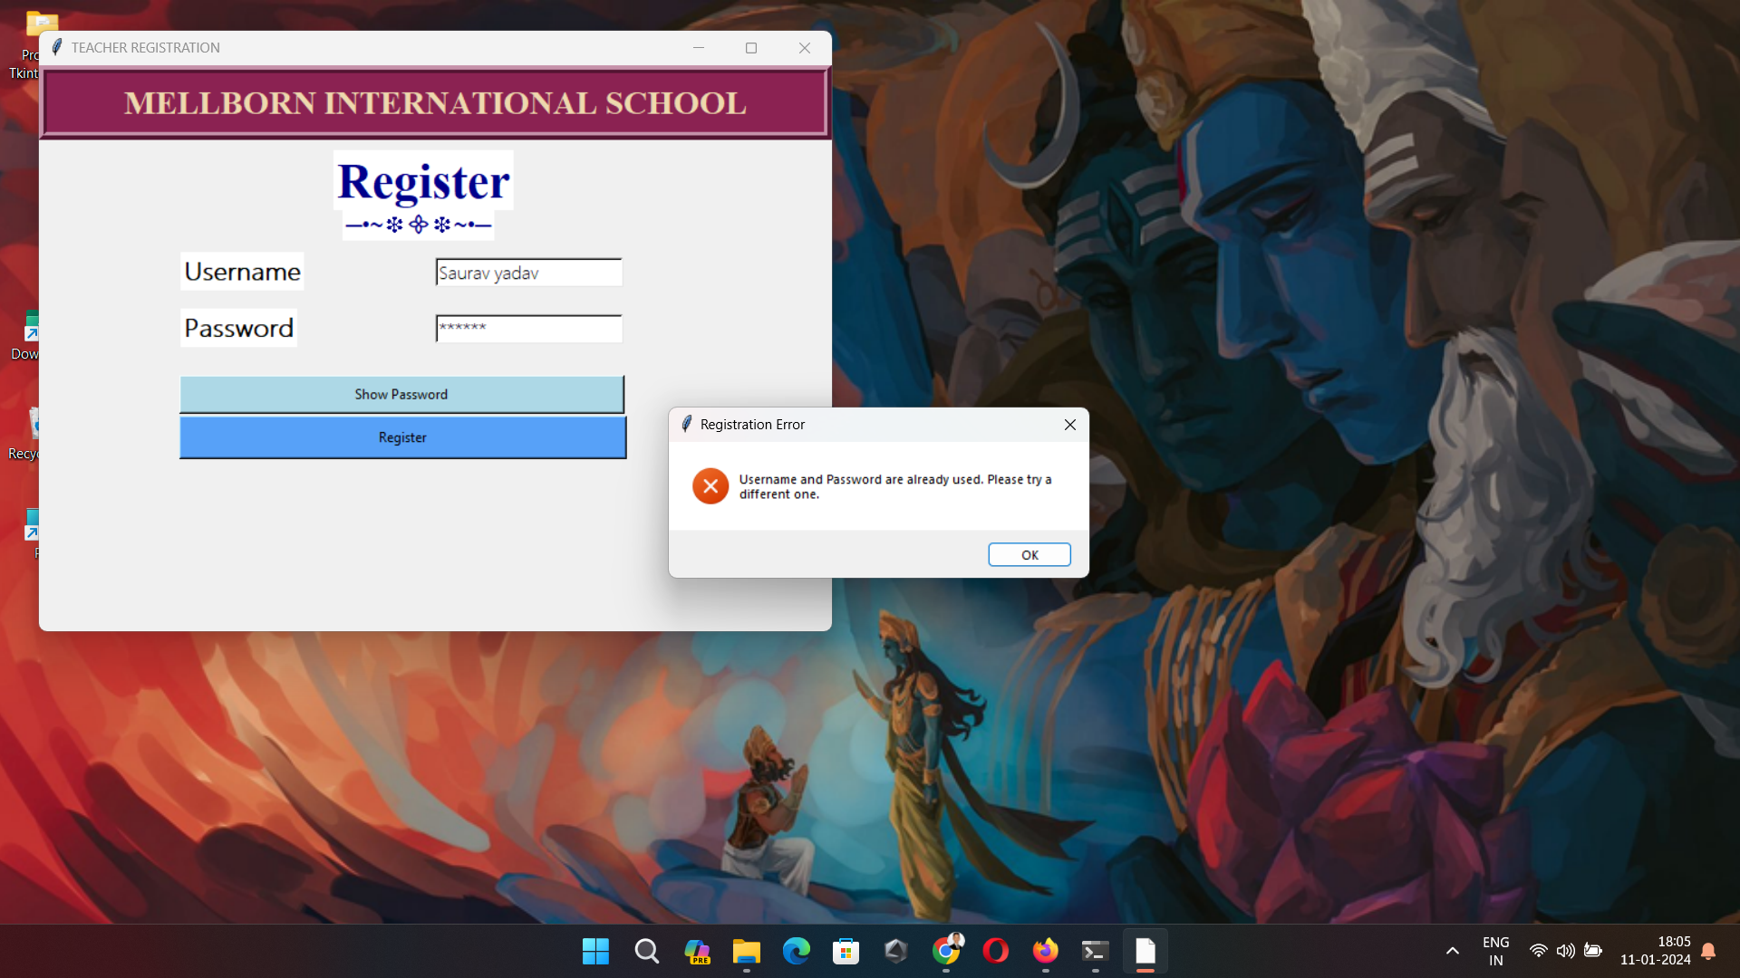

* Assume that we have done a Registration by entering new Username and Password, then the Label of **Registration Successful!**  And **Go to Login** Button will occurand if we can click on **Go to Login** Button so it can Redirect to Login Page.

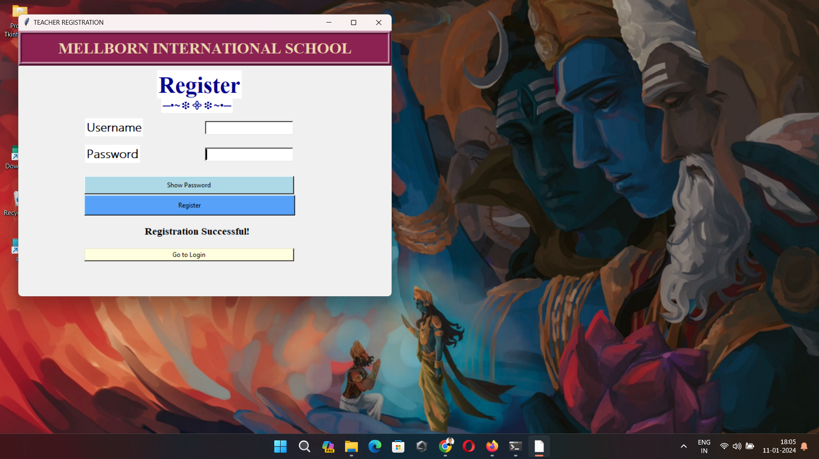

* By filling right details of user, then the **Dashboard of Attendance and Student data** will open.

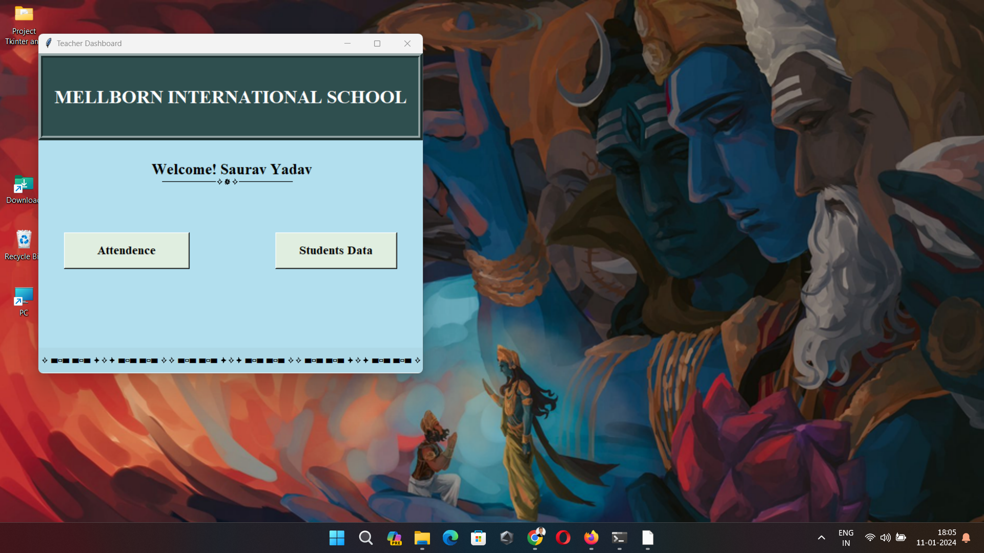

* Now Click on **Attendance** Button, then Select the date from Selection Box after select the Date of taking Attendance, then the Live Attendance page will be on the same Dashboard .

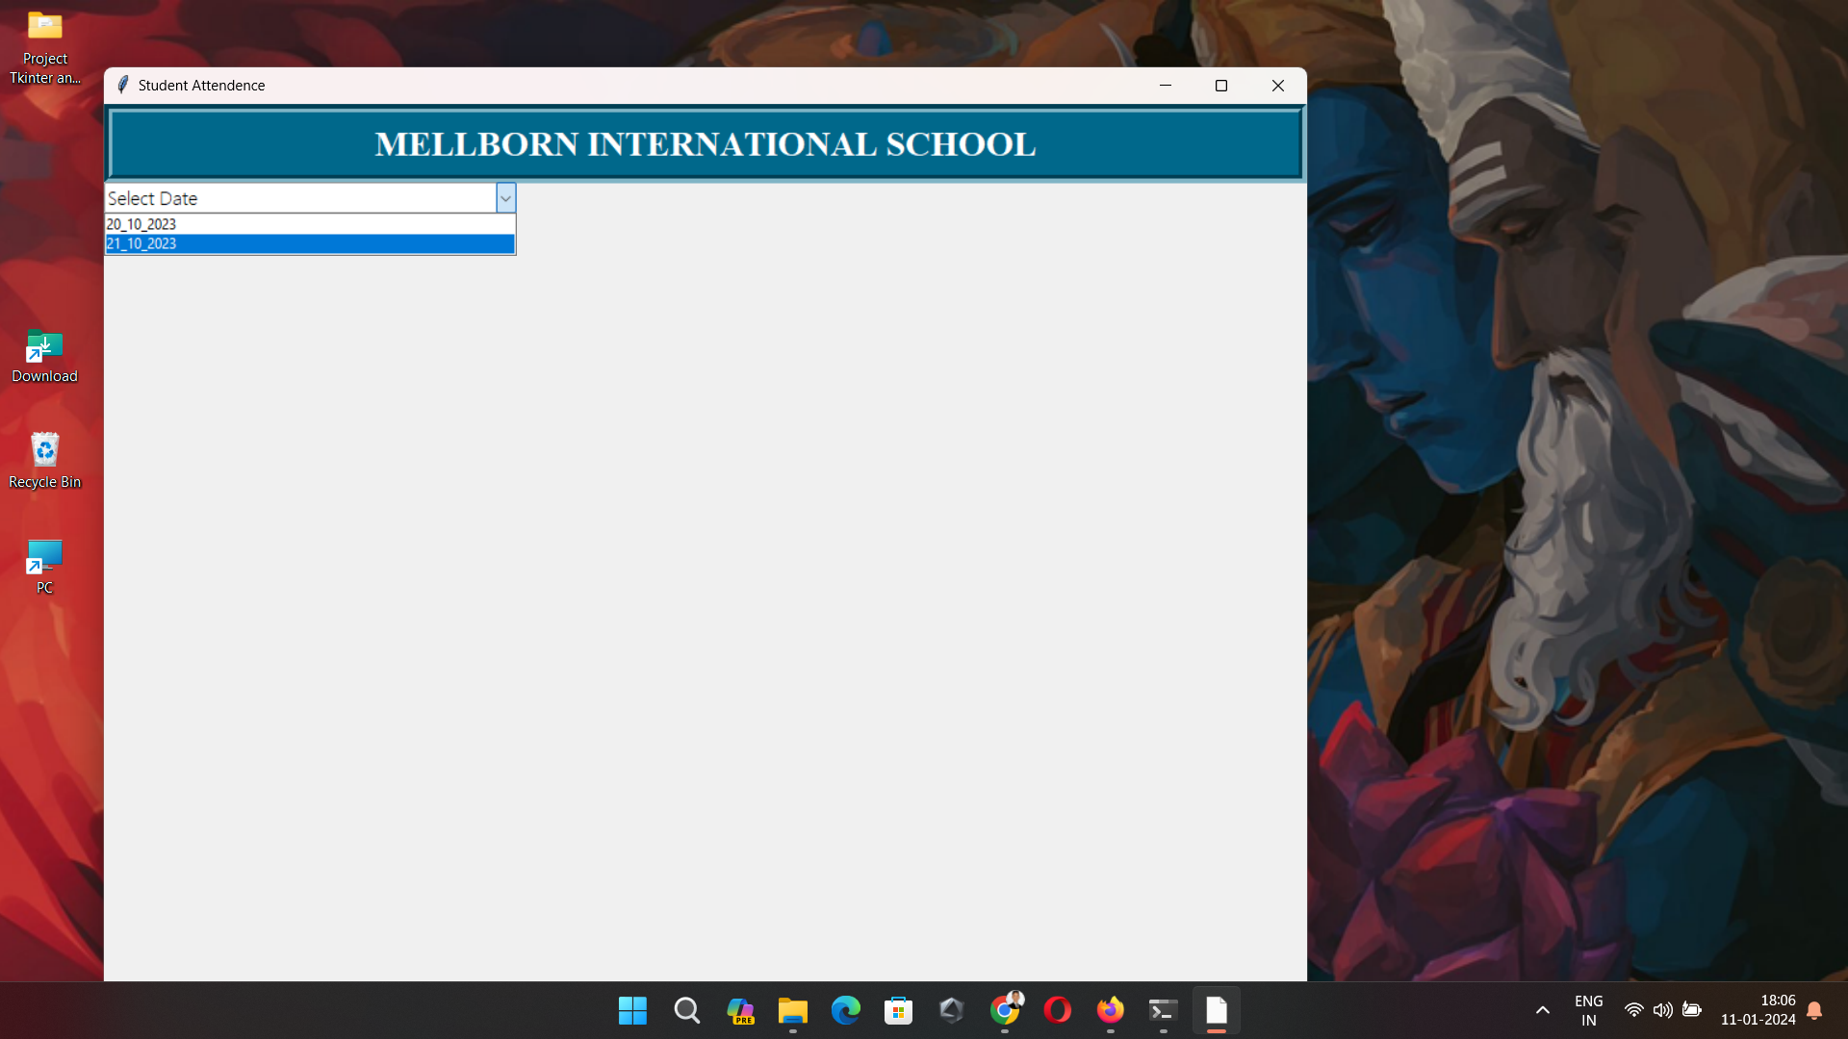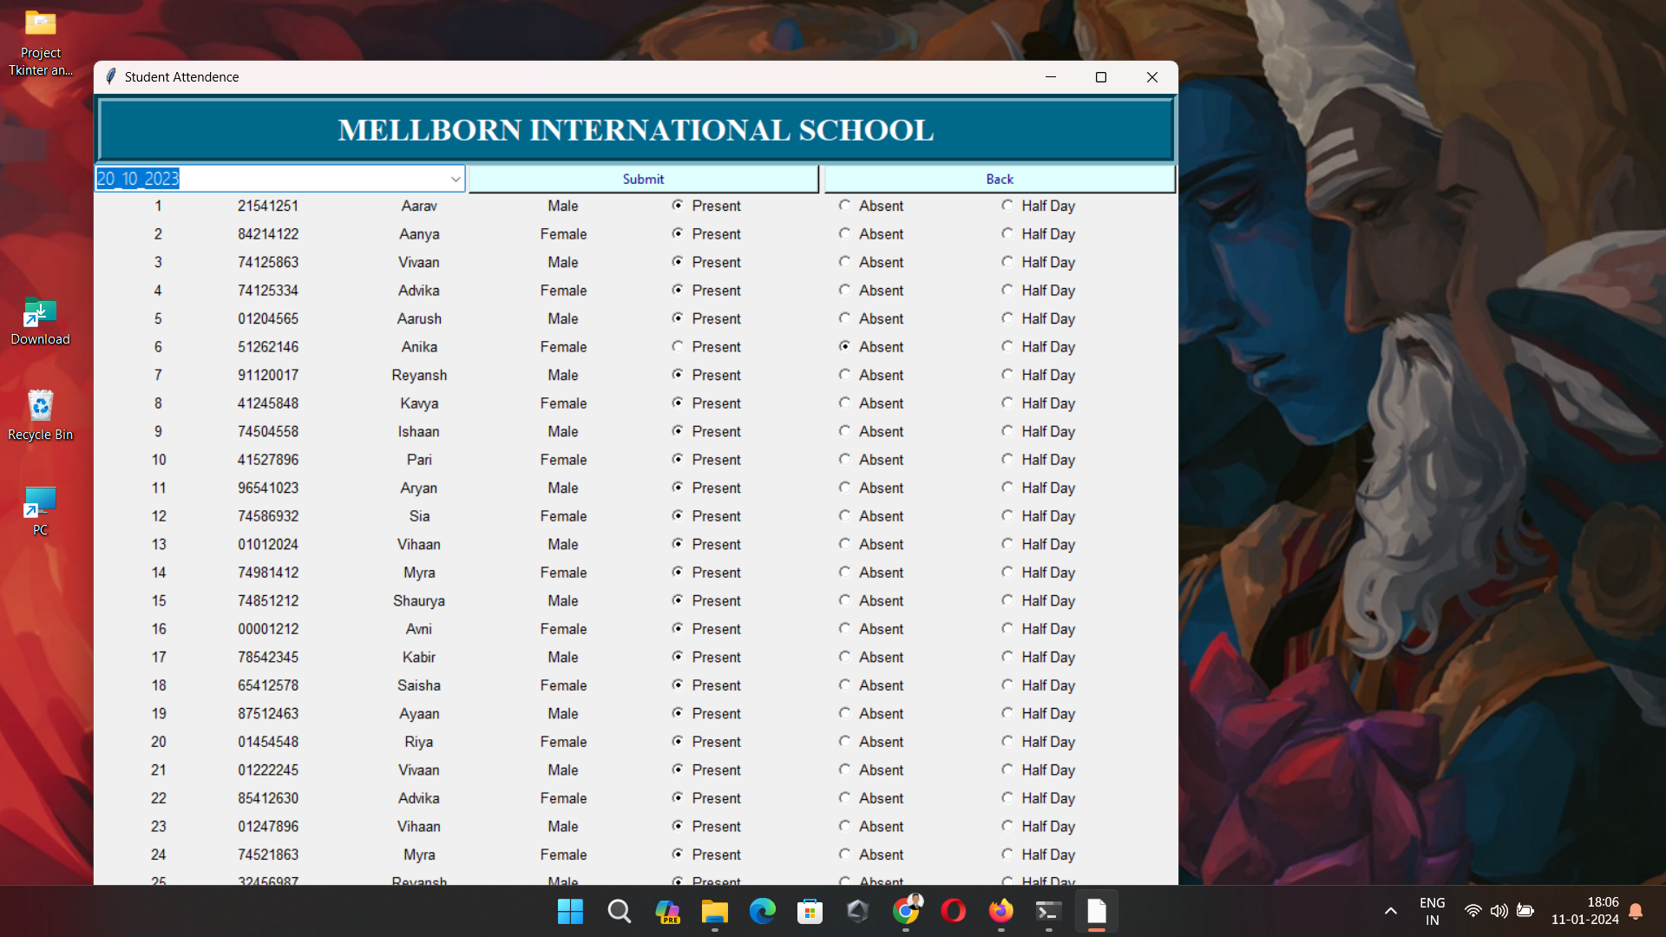

* After taking the Attendance of Students with the help of Radio Buttons of **Present, Absent and HalfDay.** We press the **Submit Button** then the Data is updated in the SQL Database

and at last going to back we have to click on **Back Button** then the **Dashboard of Attendance and Student data** will open.



* Click on **Students Data** button then the Selection Box will occurs . Lets select **Semester 2 Data** then the data of semester 2 will come on same dashboard.

